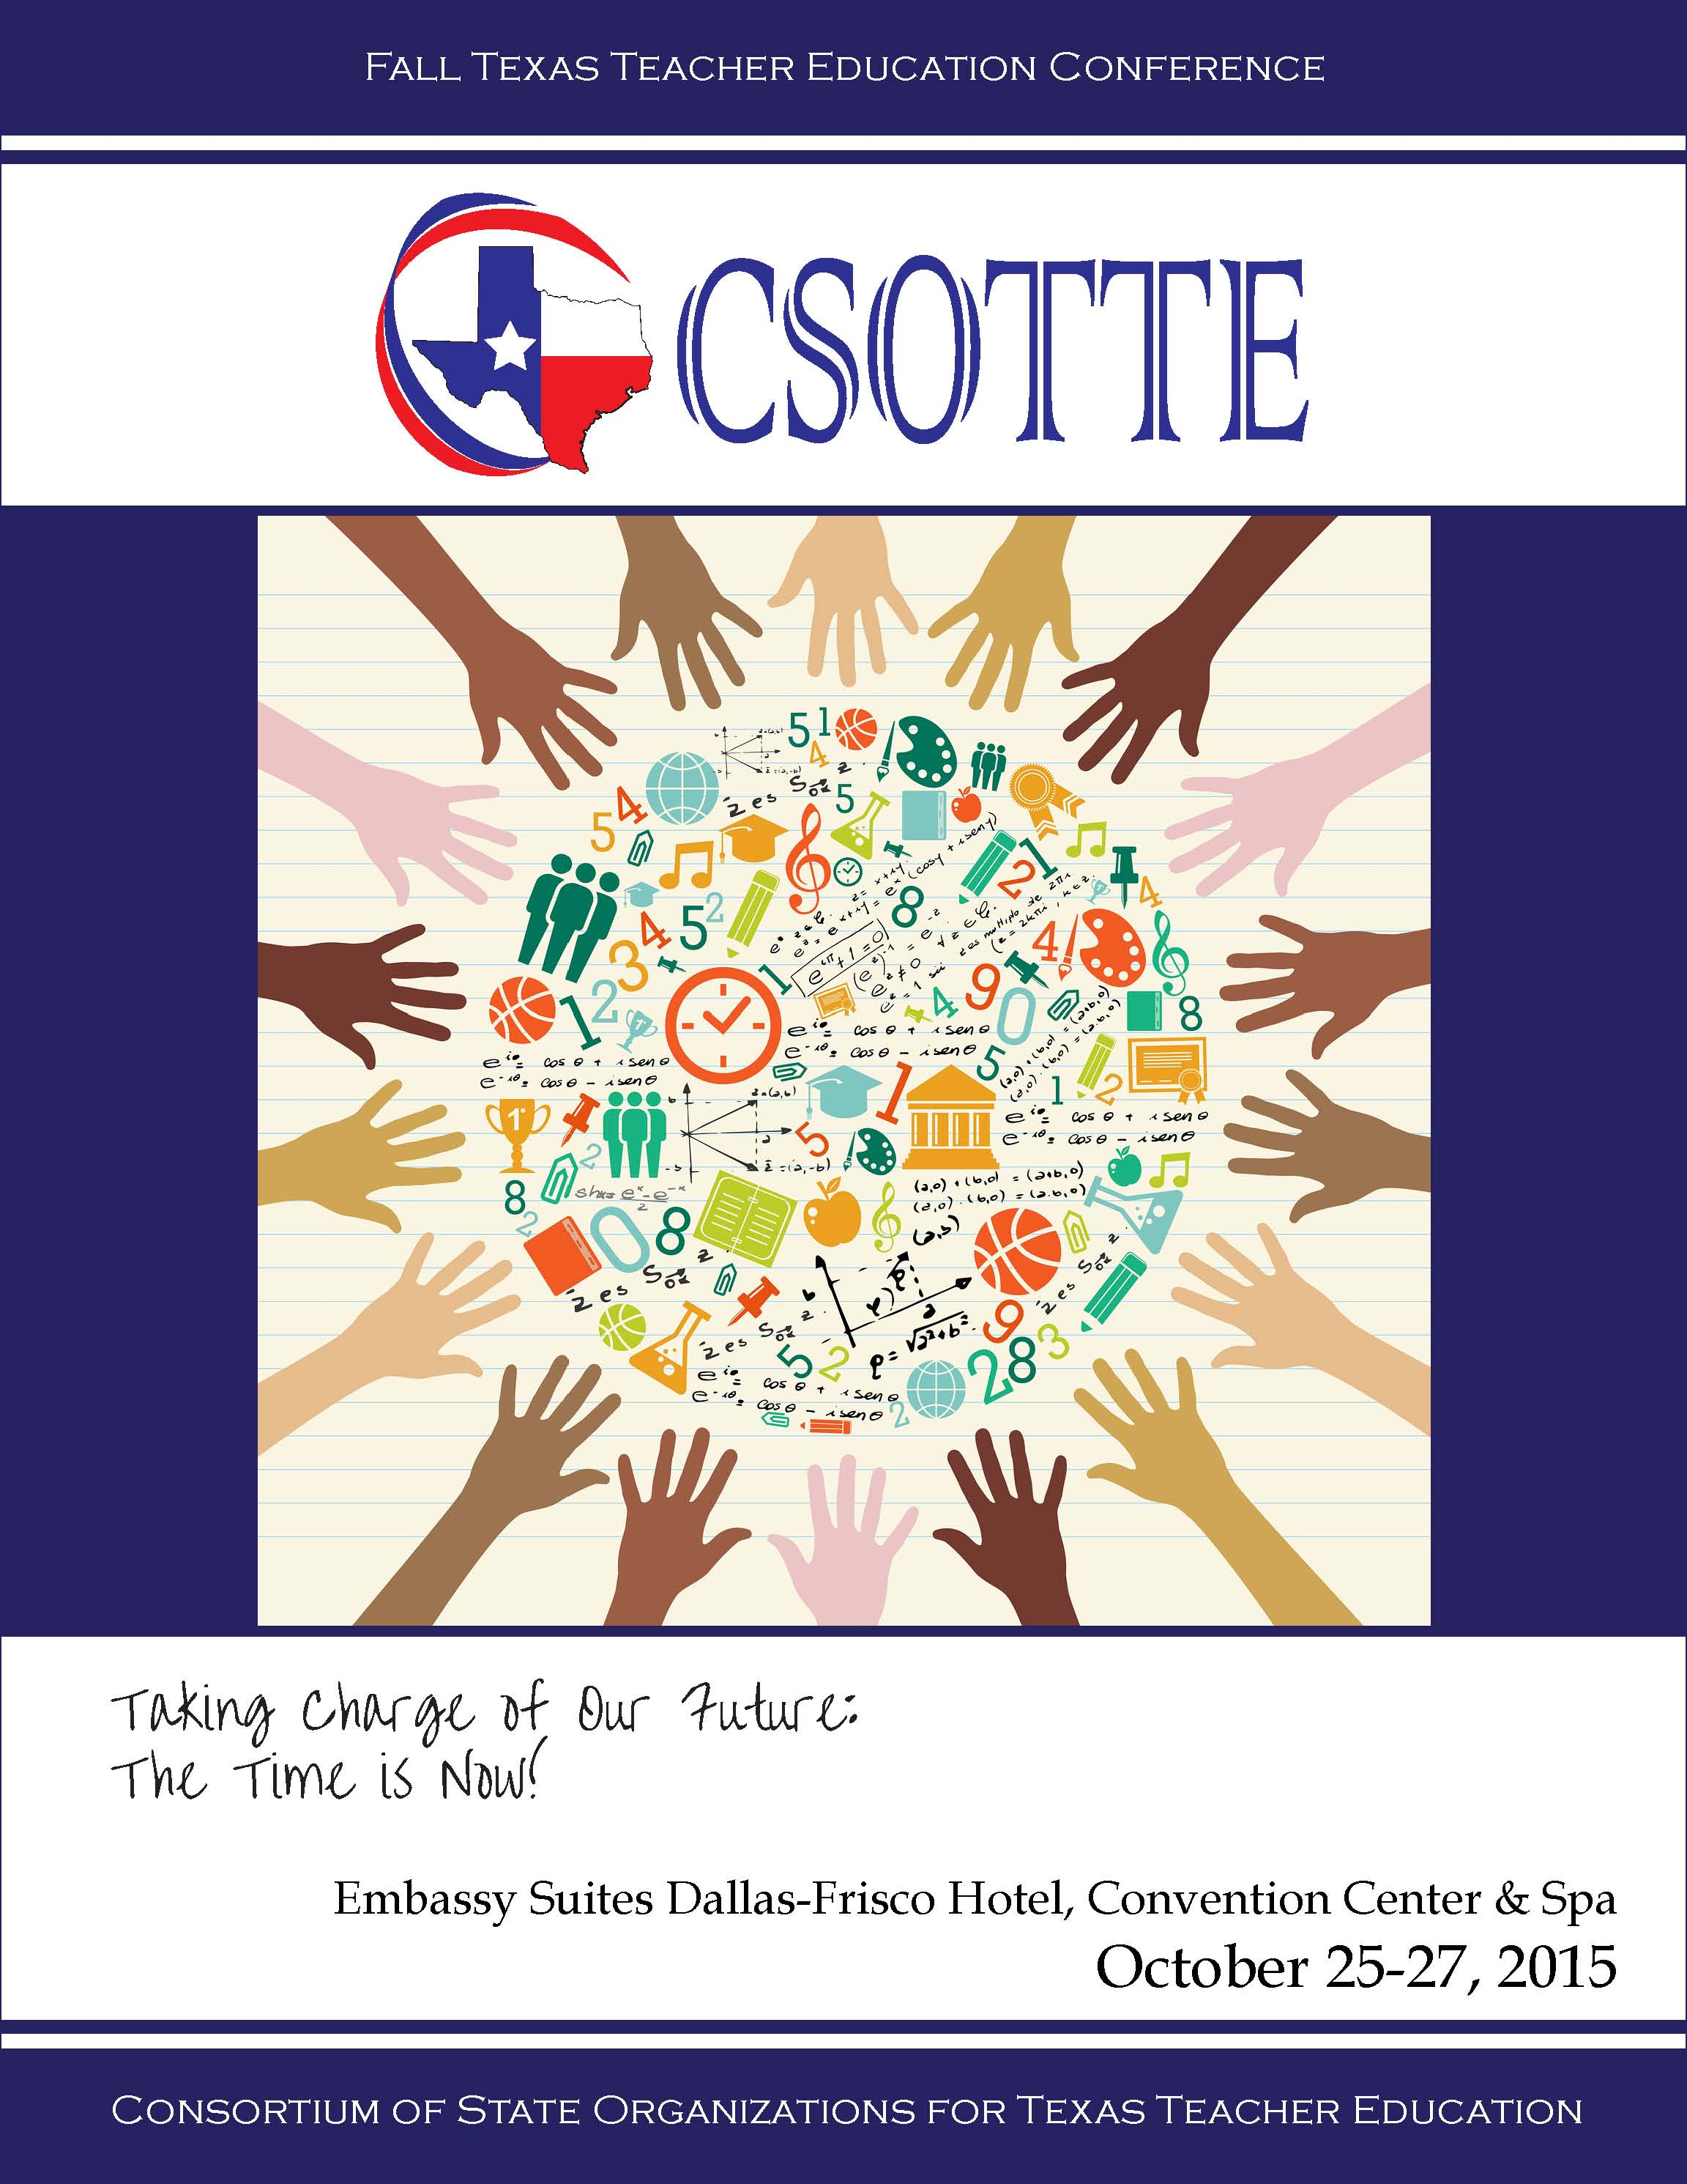

A Special Thank You to Our Sponsors!

Platinum Sponsorship
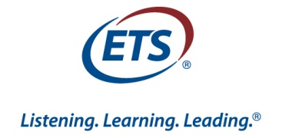

Silver Sponsorship

At last year’s conference, Superintendent John Kuhn urged us to become more proactive in shaping the future of educator preparation. He said: “If you aren’t at the table, you may be on the menu.” At both state and national levels, we have been “today’s special” for over a decade, served on a spicy puree of intense scrutiny with a heaping portion of accountability. Besides the daunting challenge of teaching new strategies requisite to Information Age learners, we are faced with:

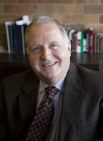
    - declining enrollment in our programs and the reality that our production never fills the need;

- a projected tsunami of teacher retirements;

- increasing vacancies for high need jobs;

- a growing school population with more special needs students;

- mounting pressure to increase our admission standards and to recruit heavily from the “best and brightest.”

Our theme asserts that we can no longer wait for a state or national initiative that embraces rethinking of a career path that will invigorate the profession and become more alluring to many students. Rather, we need to be that initiative.
In Frisco in October, we will see firsthand teachers and students engaged in “flipped classrooms” that equip learners with research and inquiry strategies that build self-responsibility. We will hear state and national experts and ponder what works and what doesn’t in raising the bar. We will have round table discussions that elicit promising strategies, brainstorm a menu of actions to take, and identify arenas we can impact. We will leave with commitments to action in our own contexts. THE TIME IS NOW!
We look forward to seeing you there!
﻿Dr. Grant Simpson﻿
2015 CSOTTE Chair
Conference-at-a-Glance

 |  | Sunday, October 25, 2015
1:00 PM | 7:00 PM | Registration | Registration 1
1:00 PM | 7:00 PM | Exhibits | Frisco Foyer 1-6
1:00 PM | 1:30 PM | TCTCT Board Meeting | Frisco 1
1:00 PM | 1:30 PM | TACO Board Meeting | Frisco 1
1:00 PM | 2:30 PM | TxATE Board Meeting | Bass-Bush
1:00 PM | 2:30 PM | TDFE Board Meeting | Frisco 2
1:30 PM | 2:45 PM | TCTCT General Meeting | Frisco 1
2:30 PM | 3:30 PM | TxATE General Meeting | Bass-Bush
2:30 PM | 3:30 PM | EDICUT Board Meeting | Erudia
2:30 PM | 4:00 PM | TDFE General Meeting | Frisco 2
3:00 PM | 3:45 PM | TACA General Meeting | Frisco 3
4:00 PM | 5:00 PM | TACO General Meeting | Frisco 1
5:30 PM | 7:00 PM | General Session I  Keynote: Grant Simpson III, Keller ISD  Immersion in Project-Based Learning: A Real-Life  Application | Frisco 6
7:00 PM | 8:00 PM | Embassy Suites Manager’s Reception | Atrium

* See conference website for Breakout Session presentation materials
** Your conference name tag is your meal ticket

Monday, October 26, 2015
6:00 AM | 8:30 AM | Atrium Breakfast for all hotel guests | Atrium
7:00 AM | 5:00 PM | Registration & Exhibits | Foyer
8:30 AM | 10:00 AM | General Session II  Keynote Speaker: A.Lin Goodwin,  Teachers College, Columbia University  The Imperative Case for Quality Teacher  Preparation: Lessons from Singapore | Frisco 6
10:15 AM | 11:00 AM | Emerging Scholar Poster Sessions | Foyer
10:15AM | 12:15PM | TACTE Executive Board Meeting | Erudia
11:00AM | 11:45 AM | Breakout Sessions I | See Program Descriptions  1A, Indian Trail (2nd floor, hotel)  1B, Bass-Bush  1C, Hamilton-Lebanon  1D, Ranger Sea Biscuit  1E, Frisco 1  1F, Frisco 3  1G, Frisco 4  1H, Frisco 5  1I, Frisco 7  Theme Roundtables, Frisco 2
12:00 PM | 1:30 PM | General Session III  Plated Luncheon **  TDFE presents Student Teacher of the Year Awards  TACA presents Student Intern of the Year Awards  TACTE Award & TxATE Award | Frisco 6
1:45 PM | 2:30 PM | Breakout Sessions II | See Program Descriptions  2A, Indian Trail (2nd floor, hotel)  2B, Bass-Bush  2C, Hamilton-Lebanon  2D, Ranger Sea Biscuit  2E, Frisco 1  2F, Frisco 3  2G, Frisco 4  2H, Frisco 5  2I, Frisco 7  Theme Roundtables, Frisco 2
2:00 PM | 4:30 PM | TACTE General Meeting | Frisco 8
2:45 PM | 3:30 PM | Breakout Sessions III | See Program Descriptions  3A, Indian Trail (2nd floor, hotel)  3B, Bass-Bush  3C, Hamilton-Lebanon  3D, Ranger Sea Biscuit  3E, Frisco 1  3F, Frisco 3  3G, Frisco 4  3H, Frisco 5  3I, Frisco 7  Theme Roundtables, Frisco 2
3:45 PM | 4:30 PM | Breakout Sessions IV | See Program Descriptions  4A, Indian Trail (2nd floor, hotel)  4B, Bass-Bush  4C, Hamilton-Lebanon  4D, Ranger Sea Biscuit  4E, Frisco 1  4F, Frisco 3  4G, Frisco 4  4H, Frisco 5  4I, Frisco 7  Theme Roundtables, Frisco 2
4:45 PM | 6:00 PM | EDICUT General Meeting | Frisco 8
5:30 PM | 7:00 PM | Embassy Suites Manager’s Reception | Atrium

* See conference website for Breakout Session presentation materials
** Your conference name tag is your meal ticket
 |  | Tuesday, October 27, 2015
7:00 AM | 8:00 AM | Coffee & Tea (Brunch served at 10:00 am) | Atrium Breakfast
7:30 AM | 10:00 AM | Exhibits | Foyer
8:00 AM | 8:45 AM | Breakout Sessions V | See Program Descriptions  5A, Indian Trail (2nd floor, hotel)  5B, Bass-Bush  5C, Hamilton-Lebanon  5D, Ranger Sea Biscuit  5E, Frisco 1  5F, Frisco 3  5G, Frisco 4  5H, Frisco 5  5I, Frisco 7  Theme Roundtables, Frisco 2
9:00 AM | 9:45 AM | Breakout Sessions VI | See Program Descriptions  6A, Indian Trail (2nd floor, hotel)  6B, Bass-Bush  6C, Hamilton-Lebanon  6D, Ranger Sea Biscuit  6E, Frisco 1  6F, Frisco 3  6G, Frisco 4  6H, Frisco 5  6I, Frisco 7  Theme Roundtables, Frisco 2
10:00 AM |  | General Session IV - TEA Information Meeting  Tim Miller, Ed.D., Director of Educator  Preparation,Testing, and Program Accountability  Marilyn Cook, Director of Educator  Certification  Brunch ** | Frisco 6

* See conference website for Breakout Session presentation materials
** Your conference name tag is your meal ticket

Emerging Scholars Track
Schedule of Events
Monday, October 26, 2015

8:00-8:30 Registration and set up posters (Foyer)

8:30-10:00 General Session (Frisco 6)

The Imperative Case for Quality Teacher Preparation: Lessons from Singapore
A. Lin Goodwin, Teachers College, Columbia University

10:00-11:15 Emerging Scholars Poster Presentations (Foyer)

11:15-12:30 Lunch on your own

12:30-4:30 Emerging Scholars Special Sessions (Frisco 9)

Welcome and Introductions:
Dr. Stephanie Talley
Abilene Christian University

Session One:
Teacher Roles and Responsibilities: Practice, Policy, and Profession
Dr. Art Hernandez
Texas A&M University Corpus Christi

Session Two:
“I Like Me!” Identity and Teaching
Dr. Stephanie Talley
Abilene Christian University

Session Three (Early Career Teacher Panel):
“Now that I am a Real Teacher . . . .”
Whitney Johnson -- Austin Elementary, 2nd Grade Math and Science
Dion Sepolen -- Creekside Elementary, 5th Grade Science
Angela Moore -- Lake Dallas Elementary, 3rd Grade Inclusion
Ashlin Bowman -- Town Center Elementary, 3rd Grade Math

Emerging Scholars Track
Poster Sessions
Monday, October 26, 2015

Foundations for Percussion: A Teacher Work Sample for 6th Grade Band
Austin Lemmons
Abilene Christian University

Comparison of Process Expectations on STAAR End-of-Course Content Examinations
Nicole Ayers
Texas A&M University-Texarkana

A Comparison of Verbs in High School Math, Science, and Social Studies TEKS
Carson Hughes, Kelsey Holder, NaTasha Fields, and Crystal Smith
Texas A&M University-Texarkana

Gauging Student Understanding Through Poetry and Expository Reading
Jake Hall
Abilene Christian University

Applying Lessons Learned Through Research Study to Future Practice in Reading Instruction
Hannah V. Lowry
Abilene Christian University

Pioneering Pathways for Future Educators
Kristen Rutherford and Jackie Abamu
Texas Woman’s University

The ABC’s of Assessment: Using the Teacher Work Sample in a Kindergarten Classroom
Kristin McNally
Abilene Christian University

Incorporating Literature through the Content Areas
Katherine Cole and Megan Liller
University of St. Thomas School of Education

Facilitating Learning through Electronic Portfolios
Leslie Gonzalez
Texas Woman’s University

Learning by Doing: Using Experiential Field Based Practices to Expand Clinical Teachers’ Pedagogical Knowledge
Charteka Webb, Melissa LeCompte, and Bethany Powell
Texas Woman’s University
Best Practices in Technology for Students’ and Teachers’ Success in the Classroom
Elizabeth Kelly Walker
Texas Woman’s University

Self-Awareness of Feelings in Young Children
Shannon King
Baylor University

MATH: the Fun and Games that “Real-World” Contains
Jaleh Mallaki
Texas A&M University - Commerce

Vocabulary: Is There a Secret Formula?
Mollie Musgrove
Baylor University

Measuring Success in Science: Student Menus v. Learning Stations
Jordan Barlow
Baylor University

Comparison of Newbery and Bluebonnet Awards in Children’s Literature
Kinsley Munoz
University of Texas at Arlington, College of Education

CSOTTE Board
Executive Board
Grant Simpson  CSOTTE Chair  St. Edwards University  grants@stedwards.edu  EDICUT Past President | Glenda Ballard  CSOTTE Chair Elect  Texas A&M University - Texarkana  Glenda.ballard@tamut.edu  EDICUT President
Amanda Rudolph  CSOTTE Board Advisor  Stephen F. Austin State University  rudolpham@sfasu.edu  CSOTTE Past Chair | Sara Langford  CSOTTE Board Secretary  Texas A&M University - Texarkana  Sara.langford@tamut.edu  TDFE President
Zach Rozell  Board Treasurer  iteachTEXAS  rozellz@iteach.net  TACA Past President | Pam Tipton  CSOTTE Executive Secretary  Pam_Tipton@sbcglobal.net  TCTCT Past President
Board Members

Shari Albright  Trinity University  Salbrig1@trinity.edu  TACTE President | Ginny Fender  University of Texas at Tyler  gfender@uttyler.edu  TACTE Executive Director | Daniella Varela  Texas A&M University - Kingsville  daniella.varela@tamuk.edu  TACO President
Christie Bledsoe  University of Mary Hardin Baylor Christie.bledsoe@umhb.edu  TxATE Vice President | Gayle Grotjan  Concordia University Texas  gayle.grotjan@concordia.edu  EDICUT | Lidia Zatopek  Harris County Dep. of Education  lzatopek@hcde-texas.org  TACA Vice President
Gayle Butaud  Lamar University  gayle.butaud@lamar.edu  TDFE President Elect | Jean Hubbartt  Sam Houston State University  jmh062@shsu.edu  TCTCT President | Marlene Zipperlen  University of Mary Hardin-Baylor  mzipperlen@umhb.edu  TxATE President
Diana Everett
TAHPERD
diana@tahperd.org
TAHPERD Executive Director

MEMBER ORGANIZATIONS

Education Deans: Independent Colleges and Universities in Texas
(EDICUT)

Texas Alternative Certification Association
(TACA)

Texas Association of Certification Officers
(TACO)

Texas Association of Colleges for Teacher Education
(TACTE)

Texas Coordinators for Teacher Certification Testing
(TCTCT)

Texas Directors of Field Experiences
(TDFE)

Texas Association of Health, Physical Education, Recreation & Dance
(TAHPERD)

Texas Association of Teacher Educators
(TxATE)

GENERAL SESSION I
Sunday, 5:30-7:00pm ~ Frisco 6

Grant Simpson III
Keller Independent School District

Immersion in Project-Based Learning: A Real Life Application

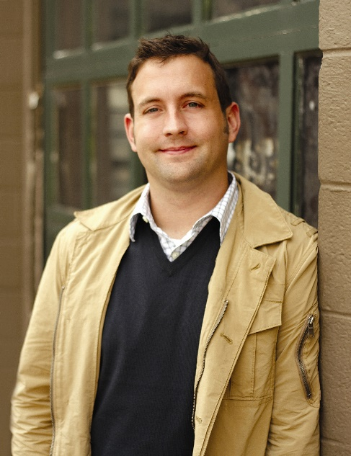
Grant W. Simpson, III is a sixth grade teacher in Keller ISD in his 13th year. In 2003 he was honored by CSOTTE as Outstanding Student Teacher of the Year. He was selected as the state’s 2008 Elementary Teacher of the Year. In 2012 he spoke to the Emerging Scholars Strand.
Grant and his students will present on their immersion in Project Based Learning (PBL), which emphasizes real world applications of learning and develops self-awareness and responsibility. Thus, it transforms a teaching model into a learning model. Come, see, and hear both teacher and student voices in this heavily collaborative journey that shifts from teaching the standards to students learning them. PBL changes both roles, and educator preparation programs need to know about this.
GENERAL SESSION II
Monday, 8:30-10:00am ~ Frisco 6

Dr. A. Lin Goodwin
Teachers College, Columbia University

The Imperative Case for Quality Teacher Preparation: Lessons from Singapore

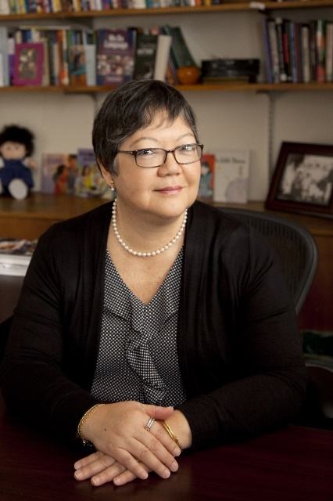
Preparing quality teachers has become a global concern as all nations look to education as the route towards upward social mobility, and teachers as the key to quality school. Thus, there is a growing desire to learn from international peers, especially those that have demonstrated strong performance on international assessment, such as PISA. In her talk, A. Lin Goodwin presents Singapore as one example of a high-achieving system that has earned accolades for educational excellence and quality teachers. Based on her research of teacher education in Singapore, she will share policies, structures, programs, and practices that support teacher learning and development across the professional continuum from student, to novice, to veteran. She will also offer insights and lessons that emerge from her research, and will conclude with recommendations for educators in the U.S. to consider as they re-imagine their own teacher education programs.

GENERAL SESSION III

Monday 12:00-1:30pm ~ Frisco 6

Awards Luncheon

CSOTTE Board: Friend of Teacher Education Award
CSOTTE presents the Friend of Teacher Education Award to recognize and reward individuals not officially connected with teacher preparation organizations and institutions, but who have made significant contributions toward improving the preparation of teachers in Texas. The recipient will be an individual who has been supportive and positive toward the mission of the organizations of CSOTTE. The first Friend of Teacher Education award was presented at the 2006 Fall CSOTTE Conference on Teacher Education.

2015 Recipient: Rick Cullors

Texas Directors of Field Experiences (TDFE): Student Teacher of the Year Awards
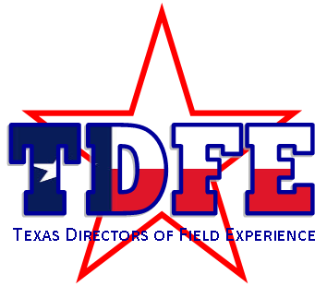 | This award recognizes a student teacher who has demonstrated, during his or her student teaching experience, an outstanding ability to plan and develop a repertoire of classroom management skills and instructional strategies that support the needs and curriculum of all students; establish effective interpersonal relationships with students, parents, faculty, and staff; and reflect about the teaching and learning process.  2015 Recipients:  - Alyssa Waldroup, University of North Texas  - Stephen VanHooser, Sam Houston State University  - Hannah Dodds, Angelo State University

Texas Alternative Certification Association (TACA): Intern of the Year Awards
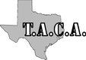 | It is a tradition of the Texas Alternative Certification Association to showcase the talent of alternatively prepared educators by selecting and honoring three outstanding individuals to receive Intern of the Year awards. The awards—a plaque and check, are presented at CSOTTE’s Annual Fall Teacher Education Conference. Recipients may also submit nomination packets to the National Association for Alternative Certification’s intern scholarship program.  2015 Recipients:  Amy Kitchel, YES Prep Teaching Excellence  Kimberlea Bass, Region 11  Victoria Wimmer, ACT Houston at Dallas

Texas Association of Colleges for Teacher Education (TACTE): Robert B. Howsam Award
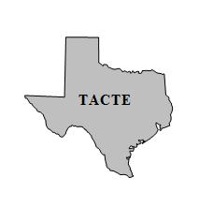 | Robert B. Howsam, who was a former Dean of the College of Education-University of Houston, was an acknowledged leader in education for many years and enjoyed a national and international reputation. He was best known for his advocacy of Competency Based Teacher Education, his dynamic leadership as a dean, and for his commitment to excellence in the preparation of educational professionals in Texas and the nation.  Recipient to be announced at luncheon

Texas Association of Teacher Educators (TxATE):
Ben E. Coody Distinguished Service Award
Dr. Coody served as the last President of the Texas Association for Student Teaching before the association became the Texas Association of Teacher Educators in 1971. He was respected for his high code of ethics, his professional zeal, and his sincerity of purpose. This award honors others who have given the same level of professional contributions to teacher education in Texas that Dr. Coody had given.
Recipient to be announced at luncheon
Ted Booker Memorial Award
In 1971, Ted Booker, TSCTE President in 1969-1970 and Dean of the College of Education at Texas Woman's University, suggested that TSCTE (predecessor of TxATE) use surplus funds to establish an award for an outstanding contribution in the field of teacher education. Because of his leadership in this area, and his untimely death in 1971, the Ted Booker Memorial Award was established in April 1972 at the TSCTE Spring Conference.
Recipient to be announced at luncheon

GENERAL SESSION IV
Tuesday, 10:00am-12:00pm ~ Frisco 6

TEA Information Session & Brunch
Panel Presentation: Texas Education Agency
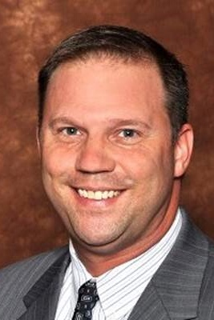 | Tim Miller, Ed.D.  Director of Educator Preparation, Testing, and Program Accountability
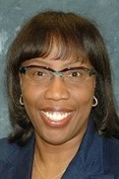 | Marilyn Cook  Director of Educator Certification

Session 1A Strand 2

Facilitator: Jerry Whitworth
Room: Indian Trail (2nd floor)

Taking Charge: Chefs or Dinner!!!
Dr. Catheryn J. Weitman & Dr. Elizabeth K. Ward Texas Wesleyan University
Dr. Selina Mireles Texas A&M International

Educators are notorious for accepting what is dictated by governing bodies. Often, we react to mandates, because we are less cognizant of the political issues that impact us. Too often we resist the temptation to be vocal and take the path of least resistance. As leaders, we need to be proactively involved with whatever impacts us, especially at the state levels. With avenues to be politically astute, we must find our voices and use them for constructive advocacy. Learn how to impact the “system” and influence state situations, as these presenters did. Be the Chef! Speak up!

Session 1B Strand 1

Facilitator: Carolyn Bray
Room: Bass-Bush

Vocabulary, Either You Have It or You Don’t: But We Can Help You to Get It!
Barba Aldis Patton, Ed.D. & Estella P. De Los Santos, Ed.D. University of Houston-Victoria

Vocabulary is challenge facing the future and present educators. The goal of this work is two-fold, first the university students must be able to pass certification tests, and then must be able to guide their students to be able to pass the STAAR test. Vocabulary presents a new challenge Mastery of words specific to a discipline such as math is not as simple as memorizing. Researchers will share how they attempt to prepare teacher candidates not only to master state tests but also be able to master the vocabulary needed to master vocabulary for the (math) discipline

Session 1C Strand 2

Facilitator: Janet Tareilo
Room: Hamilton-Lebanon

Managing the Data: One EPP’s Strategy for Maximizing Technology to Streamline Student Data from Application to Graduation and Beyond
Dr. Jannah Nerren, Mr. Joe Strahl & Dr. Judy Abbott Stephen F. Austin State University

This presentation documents the experience of one EPP in eliminating paper-based and outdated systems by integrating existing technology-based data management systems with an innovative system created within the institution. The discussion details the strategy for integrating and phasing in the systems, and the process of working with the campus Information Technology department to develop the in-house product. Each phase in the process provides opportunities to support faculty and staff while attending to the quality of teaching and learning. It creates the necessity for continuously evolving systems to manage documentation, processes for providing professional development, and oversight to facilitate continuous improvement.
Session 1D Strand 2

Facilitator: Beth Nelms
Room: Ranger Sea Biscuit

Assessing High-Leverage Practices of Teaching with Simulated Classrooms
Gary Sykes Educational Testing Services

This session will introduce participants to innovative, simulation-based, performance assessment tasks. These new assessment capabilities are being developed for the NOTE (National Observational Teaching Exam) by Educational Testing Service in collaboration with TeachingWorks an organization led by Deborah Ball of the University of Michigan. Participants will get to see what tasks and classroom simulations look like that call for prospective teachers to carry out critical classroom teaching practices (e.g., modeling and explaining content and leading classroom discussion) that have been identified as high-leverage practices through work of TeachingWorks to identify critical skills teachers must develop to support student learning.

Session 1E Strand 2

Facilitator: Deborah Sells
Room: Frisco 1

Teaching Research Methods That Students Will Remember
Christie Bledsoe University of Mary Hardin-Baylor

Research methods are difficult to teach. Statistics have deterred some students from attempting advanced degrees (Andrews & Brown, 2015). Yet, it is critical for educators to understand research in terms of identifying best practices and conducting action research. This session will include hands-on activities to illustrate engaging ways to teach both qualitative and quantitative research methods. While knowledge of research nor statistics is required to benefit from this session, active participation will be required. Participants will engage in data collection and analysis that can easily be implemented or modified for use in the college classroom.

Session 1F Strand 1

Facilitator: Marlene Zipperlen
Room: Frisco 3

Experiential Learning: Taking Special Educators to the Next Level
Dr. Kris Ward University of Mary Hardin-Baylor
Rebekah Peyton & Gena Weeks, Students University of Mary Hardin-Baylor
The University of Mary Hardin-Baylor Special Needs Lab was created to provide an opportunity for undergraduate students certifying in special education to interact with children with disabilities in a safe learning environment. Creating Experiential Learning provides students a way to hone skills necessary for future success in a special education setting. Using research-based practices taught in class, students work with children with various disabilities from the community on academic, social, and behavioral tasks. Self-efficacy has increased as a result of planning, instructing, and assessing children in the lab. Students are well prepared for student teaching and their first placement.

Session 1G Strand 2

Facilitator: Jake Hollatz
Room: Frisco 4

See, Say, Do: Student Teachers, Videography, and Student Outcomes
Lorraine Spickermann & Carol Staggs University of Texas of the Permian Basin

The Teaching Channel gave UTPB some seats for student candidates to use to demonstrate AVID strategies as part of our Teacher Preparation Initiative. Student teachers record themselves three times a semester and post the videos through the Teaching Channel. Then they have the opportunity to view the videos and make comments. The videos are on a closed channel where only invited members of our group may view the videos. Their teaching and self-awareness improved when they viewed themselves and read the comments from their supervisors and other student teachers.

Session 1H Strand 2

Facilitator: Sally Coleman
Room: Frisco 5

Cultivating Critical Literacy in the Elementary Classroom: Peeling Back the Layers of “Truth”
Dr. Debby Shulsky & Dr. Elaine Hendrix University of Houston-Clear Lake

Imagine elementary teachers actively teaching critical literacy. Children in classrooms today will be citizens of a global-minded world with intricate challenges requiring critical and creative approaches to problem solving. As such, this new generation of citizens requires experiences in education that ready them to view the world from a critical stance. Elementary teacher educators, therefore, must create learning experiences that expand the critical capacity of their students. Participants will leave this session with: 1) A broader understanding of critical literacy; 2) Inspiration to rethink and redirect current elementary teacher education curricula; and 3) Practical ideas for critical literacy classroom models.

Session 1I Strand 3

Facilitator: David Boyer
Room: Frisco 7

Transforming Pre-Service Teachers into Servant Leaders
Annette Mahan & Dana Reeger Lubbock Christian University
Brittany Holloway & Maci Mayfield, Students Lubbock Christian University

Servant leadership is the cornerstone of the teaching profession. Teachers are expected to put students’ good above those of their own and continuously self-reflect. Hence, one of the goals of Teacher Preparation Programs is to transform incoming Education majors into servant leaders who will enter schools determined to positively impact the students and adults that they interact with daily. This session discusses course work, organizations, and service project opportunities that assist students’ transformation into servant leaders.

Theme Roundtables

Facilitators: John Miazga (Table 1), Janet Williams (Table 2), Gina Anderson (Table 3)
Room: Frisco 2

Consistent with our theme, Future: The Time is NOW!, each breakout session will have a Theme Roundtable in Frisco 2 to include three tables with assigned facilitators who will guide the conversations and record the ideas shared. Come and hear the ideas and actions of others in taking more proactive roles in our profession. Share what’s happening in your work. Our specific focus will be on how to enable an effective, incentivized teacher career pathway in our schools, which consistently recruit for the profession. Instead of waiting for a top down initiative, let’s start our own from the bottom up.
Remember the stirring words of Margaret Mead:
“Never doubt that a small group of thoughtful, committed citizens can change the world. Indeed, it is the only thing that ever has.”

Session 2A

Facilitator: Wendy Storms
Room: Indian Trail (2nd floor)

Professional Ethics: Providing a Framework for Educator Decision Making
Rick Cullors & Jessica Stern Educational Testing Services
Participants will explore the preparation and assessment of educators in ethical decision-making through ETS’s new ProEthica Program. Teacher candidates are well-prepared in the knowledge, skills, and dispositions needed to be effective educators. However, knowing how to address ethical dilemmas, as well as understanding the professional risks and vulnerabilities inherent in a highly complex profession, is imperative at the preservice level. In this interactive session, participants will explore the topic of preparing and assessing candidates in ethical decision-making, including the use of an instructional educator online ethics program for educator preparation program candidates.

Session 2B Strand 2

Facilitator: Patricia Alvarez McHatton
Room: Bass-Bush

Positive Course Redesign: Survey of Exceptional Learners
Dr. Sherian L. Smith Tarleton State University

This session will provide useful information when redesigning courses for today’s learners. The session provides a before and after snapshot of an original undergraduate introduction to special education course and offers strategies and tips to consider in course redesign. The redesign presentation will address Strand 2: How Do We Adjust What We’re Doing? The focus in the redesigned course is to create an interactive component for each lesson.

Session 2C Strand 2

Facilitator: Debby Shulsky
Room: Hamilton-Lebanon

Preparing K-6 Teachers Using Two Paradigms in Teaching Content Methods Courses
Sylvia Taube & Karen McIntush Sam Houston State University

An action research was conducted on the design and implementation of two different models for teaching the content methods courses (mathematics, science, social studies) for elementary teachers taught in one semester. We compared the benefits and pitfalls of two distinct models: Integrated (single instructor) and Non-integrated (multiple instructors) based on varied quantitative measures such as TExES (EC-6 Generalist, Pedagogy and Professional Responsibilities), Teacher Work Sample, and evaluations by field supervisors and mentors. Preliminary analyses of data from 1,084 teacher candidates (2011-2015) showed no significant difference in the two subgroups. Implications for hiring instructors, scheduling classes, and evaluating programs will be discussed.

Session 2D Strand 2

Facilitator: Jean Kiekel
Room: Ranger Sea Biscuit

Student Engagement Using Social, Digital, and Cultural Media: Strategies for Content Instruction that Integrate Students’ Needs and Interests

Lisa D. Hobson, Ph.D. Prairie View A&M University
Viveca Grant, Ed.D. Texas Southern University
Marilyn Parker, Ed.D. Fort Bend Independent School District

In order for students to master the Texas Essential Knowledge and Skills, perform well on State of Texas Assessments of Academic Readiness, successfully pass End-of-Course assessments, graduate, and/or become successful citizens, educators must engage them in learning experiences. In order for pre-service educators to become effective teachers and pass Texas Examination of Educator Standard assessments, we must engage them in learning. Student engagement is meaningful participation, inquiry, and immersion in learning experiences. In this interactive session, we will discuss strategies using digital media, social media, cultural artifacts to engage K-12 learners and pre-service educators through a hands-on and project based learning approach.

Session 2E Strand 1

Facilitator:
Room: Frisco 1

Create a THRIVING Graduate Program: Attract, Develop, and Retain Quality Candidates
Kimberly Welsh, Ed.D. & Jeanie Gresham, Ed.D. Stephen F. Austin State University

There has never been a more critical time than NOW to advocate for the value of advanced knowledge in the field of teaching and learning. Value of a program is drastically different than price. What value do potential and existing graduate Candidates see in your program? Learn how to attract, develop, and retain quality Candidates in a time when school districts are eliminating stipends attached to master’s degrees.

Session 2F Strand 2

Facilitator: Deborah Sells
Room: Frisco 3

SOS for Preservice Teachers! Managing ELPS and TELPAS While Improving ELLs’ Communication Skills in Reading, Writing, Listening, and Speaking
Kathy E. Stephens, Ed.D. & Michele Staples, Ed.D. LeTourneau University

Preservice teachers in Texas must be prepared to interact effectively with English Language Learners (ELLs) in their classrooms. This presentation is designed to provide a variety of fast-paced, easy-to- implement strategies, based on research related to improving the communication skills needed to be successful when reading, writing, listening, or speaking in academic or casual settings. The strategies will be inclusive of the ELPs and designed to address skills found on the TELPAS.

Session 2G Strand 2

Facilitator: Ron Beebe
Room: Frisco 4

Collaborative Reflection: Developing “Critical” Alignment across a Program
Katie Peterson Hernandez, Elisabeth Johnson & Arcelia Luna Hernandez St. Edward’s University

This presentation focuses on the ways in which three faculty members teaching in an accredited 4-year teacher preparation program are developing and designing a cohesive sequence of courses that emphasizes faculty expertise, features of a university mission that includes commitments to social justice and critical action, with clear expectations for what pre-service teachers should understand upon graduation. In our study, we situate ourselves (identities, curricula, and teaching practices) as the objects of investigation by collaboratively analyzing our own understandings of what it means to enact cohesive, critical curricula. This process raises questions with personal, collective, programmatic, institutional, and professional significance.

Session 2H Strand 3

Facilitator: Jake Hollatz
Room: Frisco 5

Value Added Teacher Appraisal: What is it and what are the Implications?
Russell Porterfield, Bobbie Ann White & Tracy Winkler, Students University of Mary Hardin-Baylor
Dr. Randy Hendricks & Dr. Marlene Zipperlen University of Mary Hardin-Baylor

This session will cover the history and current evidence of value added teacher evaluations as well as implementation implications on students and teachers. Both fiscal and psychological costs are evaluated as this model continues to gain traction across the nation. Additionally, the new T-TESS model is examined as it brings value added to Texas in the near future. Overall, this session will inform participants to ensure positive and appropriate expectations and decisions regarding value added evaluation.

Session 2I Strand 2

Facilitator: Sara Langford
Room: Frisco 7

The Use of Social Media for Teacher Professional Development
Christie Bledsoe University of Mary Hardin-Baylor

The affordances of the Web enable teacher collaboration and growth through learning communities within Web 2.0 environments (Greenhow, Robelia, & Hughes, 2009). Through a content analysis of education organization profiles and postings on Facebook, this study examines how organizations use social networking sites as a platform to promote trends and issues in education and to promote best practices. This presentation will include a summary of current findings as well as examples of the type of information available to educators on social media websites.

Theme Roundtables

Facilitators: Darla Baggett (Table 1), Daniella Varela (Table 2), Gayle Butaud (Table 3)
Room: Frisco 2

Consistent with our theme, Future: The Time is NOW!, each breakout session will have a Theme Roundtable in Frisco 2 to include three tables with assigned facilitators who will guide the conversations and record the ideas shared. Come and hear the ideas and actions of others in taking more proactive roles in our profession. Share what’s happening in your work. Our specific focus will be on how to enable an effective, incentivized teacher career pathway in our schools, which consistently recruit for the profession. Instead of waiting for a top down initiative, let’s start our own from the bottom up.
Remember the stirring words of Margaret Mead:
“Never doubt that a small group of thoughtful, committed citizens can change the world. Indeed, it is the only thing that ever has.”

Session 3A Strand 1

Facilitator: Christie Bledsoe
Room: Indian Trail (2nd floor)

Removing Barriers to Non-Traditional Student Success: Suggestions for Institutions of Higher Education
Maria B. Peterson, Ph.D., Caroline Knight, Ph.D. & Hsiao-Ping Wu, Ph.D. Texas A&M University- San Antonio

Research indicates that students who are committed to a university will typically put in the extra effort to matriculate through, however, students who considered leaving college described dissatisfaction and had little or no connection with that institution (Freeman, Hall, & Bresciani, 2007; Raley, 2007). This presentation will offer information from a pilot study investigating potential barriers to non-traditional, undergraduate student success in a south Texas university. Suggestions and discussion will be facilitated among institutions of higher education with populations of non-traditional students in regard to student-identified barriers and how to potentially remove such barriers to increase student success and retention.

Session 3B Strand 2

Facilitator: Lisa Hobson
Room: Bass-Bush

Designing High Quality Rubrics
Dr. Lance Tomei University of Central Florida
Matthew Kaylie Educational Consultant, LiveText, Inc.

After a brief overview of a basic assessment system design strategy and its implications for rubric design, the focus will shift to the value-added of high quality rubrics including their important role in helping to improve teaching and learning in educator preparation programs. Next, examples of commonly encountered rubric weaknesses will be presented and analyzed with audience participation. Advantages and disadvantages of various rubric templates will be discussed. Finally, a possible framework for evaluating rubric quality will be suggested along with a meta-rubric designed to help assess the quality of other rubrics.

Session 3C Strand 1

Facilitator: Zach Rozell
Room: Hamilton-Lebanon

A Focus on Retention: Promoting High Impact Educational Practices in the First Year
J. Ulyses Balderas, Ph.D., Jean-Philippe Faletta, Ph.D., Ana-Lisa Gonzalez, Ph.D. & Jo A. Meier, Ph.D. University of St. Thomas

Two critical components to the health of a university are found in its enrollment numbers and retention rates. Enrollment of first-year students has decreased across campus communities. Additionally, graduation rates at four- and six-years at many schools are dismal, particularly when focusing on underrepresented student populations. Colleges, now more than ever, need to develop innovative programs to retain students and graduate them in a timely manner. Our presentation will focus on three programs developed to increase student retention and timely graduation rates by combining High-Impact Educational Practices into innovative programs targeting first-year students.

Session 3D Strand 2

Facilitator: Sandra Labby
Room: Ranger Sea Biscuit

High School Teachers’ Views of Cellular Devices as Teaching Tools
Lisa Diane Black-Fuller Huntsville ISD
Sylvia Taube & Sam Sullivan Sam Houston State University

This paper presents findings from individual interviews with 22 teachers from one high school in east Texas regarding their views and experiences in infusing cellular devices in their classrooms. Non-users (27%) of cellular devices did not see the benefits for using cellphones to teach their content areas. The occasional users (73%) allowed their students to use cellphones for researching information, taking pictures, and downloading audio files. No teacher respondent received content specific technological support. Respondents felt unprepared to incorporate cellular devices during instruction and they strongly urged for effective, need-based, and ongoing professional development by content areas in secondary education.

Session 3E Strand 2

Facilitator: Wendy Storms
Room: Frisco 1

Preparing Candidates for the PPR—An Intervention that Worked!
Elda E. Martinez, Ed.D. University of the Incarnate Word

This Teacher Certification Program (TCP) conducted a randomized, controlled pilot study to evaluate a Pedagogy and Professional Responsibilities (PPR) Review Series that was designed to prepare students for success on the TExES PPR exam. Findings indicate that the average practice test scores of students who participated in the facilitated intervention, the PPR Review Series, were nine points higher than those who did not participate in the review and all passed the state exam. This presentation will describe the format, instructional methods, and study guide used in this successful PPR Review Series.

Session 3F Strand 2

Facilitator: Gayle Butaud
Room: Frisco 3

What Does Reading and Writing Have to do with PE? Adjusting the Disciplinary Literacy Class to Meet the Needs of Preservice PE Teachers
Ann D. David, Ph.D. University of the Incarnate Word

Disciplinary literacy courses are often “the cheese standing alone” in preparation programs. By trying to meet the needs of every discipline in one class, none are fully met. This is a particularly vexing problem for the non-‐academic subjects like physical education (PE), music, art, and theatre. This presentation will, first, present provisional findings from a study that examined how preservice PE teachers use literacy for their own health and fitness and conceptualize it in their future classrooms. Second, the presentation will discuss planned adjustments for the disciplinary literacy course in the hopes of better meeting the candidates’ needs.

Session 3G Strand 2

Facilitator: Jan Seiter
Room: Frisco 4

Curriculum Planning is not for Sissies: Connecting Standards, Evidence, and the Naysayers for Quality Teacher Education Programs
Dr. Janet L Tareilo Stephen F. Austin State University

Regardless of the accreditation measures that take place outside the realm of an educator preparation program, within the framework of an EPP meeting standards and providing authentic assessments help to ensure program candidates will be of the highest quality. However, not everyone is ready to jump on the bandwagon when asked to relate course content to curriculum measures. Navigating this process with faculty is sometimes difficult and has no room for the weak of heart. This presentation details how even the naysayers will be able to align standards, build meaningful rubrics, and complete these tasks in a painless way.

Session 3H Strand 2

Facilitator: Marlene Zipperlen
Room: Frisco 5

Building Consensus Using the Delphi Method: Preservice Teachers’ Beliefs about Effective Teaching Practices
Michael Faggella-Luby & Michelle Bauml Texas Christian University

Can we change preservice teacher’s minds? This presentation reports findings from a study to identify what juniors and seniors in a university-based teacher education program believe are characteristics of effective teachers. Using Delphi methodology, the researchers collected three successive rounds of data using the online platform QualtricsTM. Findings revealed that although consensus was achieved on all survey items within cohorts, there were key differences in responses between the junior and senior years. The session concludes with discussion about how programs can replicate the Delphi self-study procedures and action planning steps. Important study limitations and roadblocks for success will be presented.

Session 3I Strand 2

Facilitator: Beth Nelms
Room: Frisco 7

Digital Native Does not Equate to Digitally Literate
Kimberly Hornsby, M.Ed. & Angelica Villafuerte, M.Ed. University of Mary Hardin-Baylor

Today’s youth are “digital natives”, having never known a life without cell phones or the internet. A common misconception is that because of the amount of time teens spend online, adolescents are well-versed in the use of technology as a whole. It is vital for educators to know that digital native students are not always digitally literate. Even with extensive online usage, teens need formal training to effectively navigate technology and produce scholarly work. Teachers are essential in helping students develop digital literacy to become responsible participants in the digital world.

Theme Roundtables

Facilitators: Daniella Varela (Table 2)
Room: Frisco 2

Consistent with our theme, Future: The Time is NOW!, each breakout session will have a Theme Roundtable in Frisco 2 to include three tables with assigned facilitators who will guide the conversations and record the ideas shared. Come and hear the ideas and actions of others in taking more proactive roles in our profession. Share what’s happening in your work. Our specific focus will be on how to enable an effective, incentivized teacher career pathway in our schools, which consistently recruit for the profession. Instead of waiting for a top down initiative, let’s start our own from the bottom up.
Remember the stirring words of Margaret Mead:
“Never doubt that a small group of thoughtful, committed citizens can change the world. Indeed, it is the only thing that ever has.”

Session 4A Strand 3

Facilitator: Alma Rodriguez
Room: Indian Trail (2nd Floor)

The Top 5 Things that Pre-Service Teachers Need to Know
Katrina Hovey, M.S. University of North Texas
Maria B. Peterson, Ph.D. Texas A&M University-San Antonio

Teachers’ professional learning is known to be based on active learning, reflective thinking, and collective participation (Darling-Hammon & Richardson, 2009; Desimone, 2009). This presentation offers participants information from the literature and personal field experiences regarding the top five things that pre-service teachers should know before entering their first teaching job and which may also ensure higher rates of success and less frustration when working with students of all ability levels. Topics that will be covered and discussed include: Response to Intervention, evidence-based practices, classroom management, differentiating instruction, and incorporating technology.

Session 4B Strand 2

Facilitator: Amanda Rudolph
Room: Bass-Bush

Telling the Study Abroad Story Digitally: Using Technology to Enhance Learning Outcomes
Karla Eidson, Ph.D., Sylvia Taube, Ph.D. & Lisa Brown Ed.D. Sam Houston State University

Study Abroad programs are becoming an increasingly vital component in developing students for the modern global community. Many Study Abroad programs exist but are not designed to meet the specific needs of pre-service teachers preparing to the meet the needs of the increasingly international student populations. We will present an innovative program utilizing digital storytelling technology to recapture the Study Abroad experience and enhance their international travel experience. Presentation attendees will actively participate in demonstrations of the digital storytelling process used in relation to a study abroad program designed for pre-service teachers. Additionally, they will interact through Q&A, response to the presentation, introduction to background research, and hand-outs.

Session 4C Strand 2

Facilitator: Renee Collins
Room: Hamilton-Lebanon

Meeting the Challenge of 21st Century Classrooms: Utilizing New Literacy Assessment with PK-12 Pre-Service Teachers
L. Karen Estes-Sykes & Carolyn Allemand University of Mary Hardin-Baylor

It seems common sense for teacher educators to model effective assessment of new literacies for pre-service teachers. However, in reality such activities are rarely employed in teacher preparation programs or in public school field experiences. By engaging pre-service teachers in real-world tasks designed to associate assessment of new literacies with relevant objectives, knowledge and skills are acquired that can be applied in a variety of contexts with PK-12 students. This presentation will highlight real-world tasks, the intent and outcomes of these tasks, examples of student work, and pre-service teachers’ responses to practical application utilizing authentic assessment with new literacies.

Session 4D Strand 1

Facilitator: Marlene Zipperlen
Room: Ranger Sea Biscuit

The Roller Coaster of Retirement, Recruitment and Retention: Strategies for Building a Teacher and Administrator Candidate Pool During Difficult Economic Times
Donna Glassman-Sommer, Marvin Lopez & Jesse Coronado Tulare County Office of Education
This presentation will review the current retirement wave of teachers and administrators in the state of California as well as best practices for recruitment, selection, development and retention found by the California Teacher Recruitment Program (CTRP) and New Teacher & Leadership Development (NTLD). We will share lessons learned through CTRP and NTLD that have helped us continue to grow our teacher and administrator programs during difficult economic times. In addition, participants will discover procedures for building collaborative bridges with universities, alternative certification programs, county offices, and school districts for the purpose of meeting the needs of our schools.

Session 4E Strand 2

Facilitator: Patricia Alvarez McHatton
Room: Frisco 1

Meeting the Content Knowledge Needs of Elementary Teacher Candidates: A Proactive Approach
Karla Hamilton, Dr. Jeanie Gresham & Dr. Elizabeth Vaughan Stephen F. Austin State University

This session focuses on strategies employed by one university to meet the need for increased content knowledge preparation for elementary teachers. Data from both the TExES EC-‐6 Generalist exam and the early testing of the EC-‐6 Core Subjects exam was analyzed to determine need areas. A multi-‐pronged approach was used to meet identified needs in the content areas, including working with education faculty, arts and sciences faculty, and candidates. Resulting changes have included improved course alignment with Texas Educator Standards, redevelopment of courses, and the development of new courses.
Session 4F Strand 1

Facilitator: Jan Seiter
Room: Frisco 3

Creating Sustainable Partnerships in a Teacher Education Program
Dr. Leslie Loughmiller & Dr. Katie Peterson St. Edward’s University

This presentation will focus on the ways in which a small university teacher education program forged and sustained mutually beneficial partnerships with community schools and the benefits of these partnerships therein. Research has shown that students participating in high-quality field-based learning experiences creates circumstances through which preservice teachers feel more engaged in learning the art of teaching; thus, build more complete and robust philosophies about pedagogies. In this presentation we describe features of the field experience that provide opportunities for preservice teachers to develop understandings about the complexity involved in juggling multiple social and academic goals related to teaching (Hammerness, et, al., 2005). Specifically, we will highlight the ways in which partnerships are forged and sustained as well as small group tutoring contexts in which preservice teachers plan, design, and implement tutorials for elementary aged children and the benefits of this type of field experience.

Session 4G Strand 2

Facilitator: Lidia Zatopek
Room: Frisco 4

Field Experience in an Informal Science Setting
Ratna Narayan University of North Texas – Dallas
Dr. Lori Petty University of Mary Hardin-Baylor

Participants in this research study were pre-service elementary teachers enrolled in an EC-6 science methods class in spring 2014, fall 2014, and spring 2015 semesters with a 20-hour field experience component at a science museum. Research questions investigated the effect a field experience at a science museum had on pre-service teachers’ science teaching self-efficacy and what factors impacted the pre-service teachers’ science teaching self-efficacy during this field experience. Data consisted of pre/post surveys, course assignments, reflections and interviews. The qualitative and quantitative data cohesively revealed participating in the field experience at the science museum positively impacted participants’ science teaching self-efficacy.

Session 4H Strand 3

Facilitator: Lisa Hobson
Room: Frisco 5

Public School-University Research Collaboration—First Steps
Catherine Horn, Ph.D. University of Houston
Sherri Lowrey, M.S. CREATE

University teacher preparation programs cannot produce effective teachers in isolation from public schools. Although the two institutions are interrelated and share common interests, they have trouble connecting their work. As a way to bridge the gap between educational theory and practice, CREATE promotes the concept of responsive research. Because conducting collaborative problem-centered research is difficult, creating a shared vision is essential. And although there are many ways to create a shared vision, this session will explore the use of a logic model to co-develop compelling and mutually beneficial research questions around problems of teacher preparation and teacher practice.

Session 4I Strand 2

Facilitator: Beth Nelms
Room: Frisco 7

Keep Calm and Audit On
Donna Brasher Texas Tech University
Wanda Dyess Lubbock Christian University
TEA continues the 5 year Audits for each Teacher Preparation Program. How does a Program prepare and carry it out, whether it be a personal visit by TEA staff or a Desk Audit? Come get some ideas from a Preparation Program who just completed an Audit and another Program as they Prepare. We will answer all of your questions and try to alleviate those panicked moments when you are informed your audit is about to begin. Hear first-hand experience and suggestions to make your Audit run smoothly.

Theme Roundtables

Facilitators: Laura Allen (Table 1), Daniella Varela (Table 2)
Room: Frisco 2

Consistent with our theme, Future: The Time is NOW!, each breakout session will have a Theme Roundtable in Frisco 2 to include three tables with assigned facilitators who will guide the conversations and record the ideas shared. Come and hear the ideas and actions of others in taking more proactive roles in our profession. Share what’s happening in your work. Our specific focus will be on how to enable an effective, incentivized teacher career pathway in our schools, which consistently recruit for the profession. Instead of waiting for a top down initiative, let’s start our own from the bottom up.
Remember the stirring words of Margaret Mead:
“Never doubt that a small group of thoughtful, committed citizens can change the world. Indeed, it is the only thing that ever has.”

Session 5A Strand 1

Facilitator: Amanda Rudolph
Room: Indian Trail (2nd floor)

Supporting Transfer Students via a Learning Community
Marcia L. Montague, Ph.D. Texas A&M University

Learning Communities can have a marked impact on student participants. This session will share the successes and challenges of one transfer learning community (TLC), aimed at increasing retention of students in three majors: special education, bilingual education, and child professional services. Information will be shared on the impact our particular TLC has had on students who have participated. Sample agendas, timelines, activities, and pre/post surveys will also be shared.

Session 5B Strand 2

Facilitator: Christie Bledsoe
Room: Bass-Bush

Collaboration and Connections: Investigating the Use of Teacher Candidate-Created Protocols to Connect Research to Classroom
Jannah Walters Nerren & Tracey Covington Hasbun Stephen F. Austin State University

The purpose of this study was to investigate the effects of having teacher candidates collaboratively create observation protocols based on assigned readings of current research on classroom practices, in order to connect research to practice. In addition, the study examined the extent to which mentor teachers modeled current research-based practices as measured by teacher candidate-created observation protocols. Finally, the study explored which areas of research-based practices were observed the most and the least. Findings indicated that teacher candidates had an overall positive experience utilizing the protocols to observe for best practices because of the concreteness of which specific practices for which they were observing. Additionally, it was found that utilization of the protocols created an awareness of the best practices being used, but also shed light on the importance of individualizing the practices to meet student needs, as well as the individualization in utilization based on mentor teacher personalities. The project indicated that many of the practices that the teacher candidates selected for their protocols were being used in the mentor classrooms, most heavily in the areas of lesson planning and reading instruction.

Session 5C Strand 2

Facilitator: Renee Collins
Room: Hamilton-Lebanon

Solving Universities’ “How Should We Teach?” Lesson Planning Conundrum
Dr. Agnes (Aggie) I. Stryker & Dr. Laura Isbell Texas A&M University-Commerce

Today there are many different formats of lesson planning authored by specialists, text books, school districts, and schools. This melee provides confusion for pre-service teachers and new teachers. It is also a problem for teacher education program. Which lesson plan format do they teach and emphasize? How do teacher education programs teach what new teachers will need no matter where they teach? This session will unearth the foundation or four basic components of all lesson plans. Teacher Educator programs can use this core as a basis to help teachers adapt districts’ or schools’ lesson plan without compromise or confusion.

Session 5D Strand 2

Facilitator: Catheryn Weitman
Room: Ranger Sea Biscuit

Pre-Service Bilingual Teachers and Their Spanish Academic Language Proficiency as Measured by the BTLPT
Alma D. Rodríguez, Ed.D., Sandra I. Musanti, Ph.D. & Gloria Patricia Quesada, Ed.D. University of Texas Rio Grande Valley

This presentation shares preliminary results of a study designed to explore pre-service bilingual teachers’ perceptions of their Spanish academic language development and their performance on the Bilingual Target Language Proficiency Test (BTLPT). Recommendations for bilingual teacher preparation will be highlighted.

Session 5E Strand 2

Facilitator: Debby Shulsky
Room: Frisco 1

Employing Culturally Responsive Pedagogy with Picture Books: A Look at Gender Representation
Lori Ann Falcon, Ph.D. University of the Incarnate Word

Caldecott Awarded books are the most common literature encountered by primary students. The characters they see and relate to provide important information about how they make sense of the world. These books often present gender roles (Weitzman, 1975) that influence students about what they should and can become (Albers, 1996). They also condition students to accept particular ways of behaving (Fox, 1993). This presentation provides a current content analysis of Caldecott Awarded books providing methodical research of gender references and images. It also provides a discussion surrounding culturally responsive pedagogy challenging the status quo and critically examining children’s literature.

Session 5F Strand 2

Facilitator: Daresa Voss
Room: Frisco 3

Building a Better Mousetrap . . . Assessment
Dr. Janet Hindman, Dr. Judy Williams, Dr. Betty Coneway & Dr. Beth Garcia West Texas A&M University

The question is not about how to build a better mousetrap, but rather, how do you build a better assessment? An intensive journey towards building a more inclusive and sustained evidence-based culture within our department of education has yielded more collaborative and collegial efforts by faculty members to create higher quality assessments for both the classroom and program evaluation. These efforts have generated a matrix design process for aligning and measuring multiple learning outcomes across multiple programs. This culture of evidence (Salazar, 2014) through assessment is now embedded in our department’s current actions and practices. This is our story.

Session 5G Strand 1

Facilitator: Jean Kiekel
Room: Frisco 4

Enhancing Developing Teachers’ Social-Emotional Skills: A Key Ingredient for Teacher and Student Success
Randy Soffer University of St. Thomas
Jenna Maksymick, Student University of St. Thomas

Teacher quality encompasses more than cognitive competencies. Social-emotional skills are also important for teaching success. Social-emotional skills impact student teacher relationships, classroom management, instruction, and teacher stress/burnout. In particular, social-emotional skills help teachers to be empathetic and sensitive to student needs. This helps teachers to build rapport with their students. Research indicates that when students have high quality relationships with teachers, their academic achievement improves. This session will report on the design, findings, and implications of a recently completed pilot study on the impact of coaching on social-emotional growth involving undergraduate teacher candidates.

Session 5H Strand 2

Facilitator: Marlene Zipperlen
Room: Frisco 5

Data Talks…Instruction Walks
Karen Dunlap, Ed.D. Texas Woman’s University
Hannah McFerren, Teresa Flores & K’Leigh Watts, Student Teachers Texas Woman’s University
Teacher quality continues to be a leading priority in Texas schools. In the current climate of high stakes testing, teachers are expected to understand (from day one) how student test score data impact the effectiveness of their instruction. Not only must novice teachers grasp this concept; they must also be proficient in the translation and transformation of testing data into pedagogically sound strategies and appropriate instructional interventions. This session examines the process students in an instruction/assessment course navigated as they disaggregated authentic school district STAAR data and created (a) instructional strategies and interventions based on data findings and (b) a presentation of findings applicable to either a parent information meeting or grade level/dept. meeting.

Session 5I Strand 2

Facilitator: Beth Nelms
Room: Frisco 7

How Student Teachers Do I.T.
Annette Mahan & Josh Wheeler Lubbock Christian University
Ryan Green Plainview ISD
Victoria Mahan Frenship ISD

Technology integration is as unique as the teachers using the tools. Without proper training of how to utilize technology effectively in the classroom, many student teachers and first year teachers fail to implement these tools. This session describes the Instructional Technology courses used to train pre-service teachers, and how student teachers and beginning teachers are integrating the technology they have learned. Two public school teachers will share their experiences of transitioning to the classroom and some of their favorite tools that engage students in meaningful ways. Tools demonstrated include: iMovie, Raptivity, Knowledge Nuggets (on-demand professional development video series), Chatterbox, and Kahoot.

Theme Roundtables

Facilitators: John Miazga (Table 1), Lidia Zatopek (Table 2), Elaine Hedrix (Table 3)
Room: Frisco 2

Consistent with our theme, Future: The Time is NOW!, each breakout session will have a Theme Roundtable in Frisco 2 to include three tables with assigned facilitators who will guide the conversations and record the ideas shared. Come and hear the ideas and actions of others in taking more proactive roles in our profession. Share what’s happening in your work. Our specific focus will be on how to enable an effective, incentivized teacher career pathway in our schools, which consistently recruit for the profession. Instead of waiting for a top down initiative, let’s start our own from the bottom up.
Remember the stirring words of Margaret Mead:
“Never doubt that a small group of thoughtful, committed citizens can change the world. Indeed, it is the only thing that ever has.”

Session 6A Strand 3

Facilitator: Alma Rodriguez
Room: Indian Trail (2nd floor)

Using Student Data on Test Preparation to Inform Education Preparation Programs
Esdras Cantao Certify Teacher

There is an increased emphasis by the federal government for states to truly hold teacher preparation programs to a clear standard of quality based on student outcomes. Multiple measures to assess teacher training program quality are in the works. Feedback systems to drive program changes are the tools of choice. This presentation describes an existing customizable data set tool that includes information on candidates’ knowledge and skill on the content they will be teaching in the classroom and how it helps drive performance improvement in the competency tests. Several examples will be shared in an interactive session with the audience.

Session 6B Strand 3

Facilitator: Catheryn Weitman
Room: Bass-Bush

Gifted Education for Bilingual Students: Promising Potential
Dr. Patsy J. Robles-Goodwin & Dr. Kimberly M. Tyler Texas Wesleyan University

In order to best meet the unique needs of our bilingual gifted students, we must first be able to identify who these students are. This session will help school districts and teachers identify characteristics prevalent in this under-identified and underserved population. Issues common to gifted bilingual students will also be discussed in an effort to not only properly identify and service, but to nurture these students in the talent development process.

Session 6C Strand 2

Facilitator: Sara Longford
Room: Hamilton-Lebanon

The Time Is Now for Family and Community Engagement
Mary M. Harris & M. Jean Keller University of North Texas

Years of research confirm both the relationship between family engagement and student success and the failure of teacher preparation to address this priority. The community-based emphasis of HB 5 and increasing competition among schools elevate the importance of school engagement of all families in their children’s education. Partners in Education: The Dual Capacity-Building Framework for Family Partnerships (Mapp & Kuttner, 2013) sets a new vision for this work. This priority must be emphasized in teacher preparation programs so candidates are well prepared to engage all families in assuring children’s academic and career success.

Session 6D Strand 3

Facilitator: Jim Todd
Room: Ranger Sea Biscuit

Evidence-Based Practices in Classroom Management: What Our Teachers Should Know
Diane Myers, Ph.D. Texas Woman’s University

This presentation will explore how to best prepare teachers to implement evidence-based practices in classroom management. These practices include (a) maximizing structure, (b) establishing and teaching expectations, (c) actively engaging students, (d) supporting appropriate behavior, and (e) discouraging inappropriate behavior (Simonsen & Myers, 2015). The presentation will provide the conceptual framework for these practices; in addition, there will be an overview of the five categories and applied examples for each. Other topics include cultural considerations in classroom management and incorporating effective classroom management training into teacher preparation programs.
Session 6E Strand 3

Facilitator: Zach Rozell
Room: Frisco 1

Challenging the Ethics in Educational Leadership: Using Social Justice Action to Disrupt the Rhetoric of the Dominant Discourse
Larry C. Bryant, Ph.D. University of North Texas at Dallas
Gina Stevenson, M.S. Mansfield Independent School District
Sheila Williams, M.S. Dallas Independent School District

In exploring the current landscape of educational discourse, many unethical policies and pedagogies have resulted in unintended consequences. Historically, educational policies have erred when restricting the Constitutional liberties of marginalized groups, however, in many instances these policies were solely enacted to silence civil disobedience. For participants, after one year of taking a social justice course, they were charged with exploring the impact of the injustices in educational policies and pedagogy. Specifically, they were tasked with imagining how they inadvertently maintained the social oppression of others. Additionally, participants discuss how their experience has benefitted them in addressing oppressive educational discourse.

Session 6F Strand 3

Facilitator: Carolyn Bray
Room: Frisco 3

Innovative Collaboration through the Mind, Brain, and Education Research Schools Network
Marc Schwartz & Jeanne Gerlach University of Texas-Arlington

The presentation focuses on the revitalization of John Dewey’s concept of the laboratory school through a collaboration between the SW Center for Mind, Brain and Education at the University of Texas-Arlington and Arlington ISD. The collaboration seeks to identify meaningful research agendas that respect and support the agendas of practitioners, researchers and policy makers. A major vehicle that facilitates this process is the new master’s degree in Mind, Brain and Education; a two-year degree that allows students to use ideas from the cognitive neurosciences and apply them in traditional and non-traditional learning contexts.

Session 6G Strand 1

Facilitator: Amanda Rudolph
Room: Frisco 4

From Guest to Partner: Building and Sustaining Mutually Beneficial Relationships with Local Schools
Phil Roberson, Ph.D. & Andrea Pawelek, M.A. Texas A&M International University

This presentation provides an overview of a sustained university-public school partnership that provides one-on-one literacy intervention for school-identified struggling readers. Students served are economically disadvantaged English language learners in grades 1-3. Tutors are pre-service teacher candidates. Emphasis is on “win-win” partnership building, shared goals and resources, and moving beyond the “guests-in-the school” status as teacher educators.

Session 6H Strand 2

Facilitator: Paula Hollis
Room: Frisco 5

Short Term Study Abroad: Creating Culturally Responsive Teachers
Paula Griffin, Ed.D. Stephen F. Austin State University

This qualitative study included four female first year teachers who shared a common study abroad experience prior to initial certification. Participants studied abroad in Italy for ten days investigating various educational settings and cultural sites and were involved in a research study to determine perceptions related to cultural and self-awareness. More than twelve months later each teacher participated in three semi-structured individual tiered interviews to determine how the experience affected instructional pedagogy. The study revealed unique applications of perceptions related to cultural and self-awareness learned while abroad.

Session 6I Strand 2

Facilitator: Lidia Zatopek
Room: Frisco 7

International Travel: Impacting Pre-Service Teachers’ Experiences
Lorrie Webb, Ed.D. & Robin Kapavik, Ph.D. Texas A&M University-San Antonio

Have you ever thought about leading pre-service teachers on a study abroad trip? Join us to learn about our experiences leading future teachers to international destinations. In addition to discussing what worked well and what didn’t work well, we’ll share our ongoing research project findings and culminating student website projects.

Theme Roundtables

Facilitators: John Miazga (Table 1), Dawn Parker (Table 2), Daniella Varela (Table 3)
Room: Frisco 2

Consistent with our theme, Future: The Time is NOW!, each breakout session will have a Theme Roundtable in Frisco 2 to include three tables with assigned facilitators who will guide the conversations and record the ideas shared. Come and hear the ideas and actions of others in taking more proactive roles in our profession. Share what’s happening in your work. Our specific focus will be on how to enable an effective, incentivized teacher career pathway in our schools, which consistently recruit for the profession. Instead of waiting for a top down initiative, let’s start our own from the bottom up.
Remember the stirring words of Margaret Mead:
“Never doubt that a small group of thoughtful, committed citizens can change the world. Indeed, it is the only thing that ever has.”

Embassy Suites Dallas-Frisco Hotel, Convention Center & Spa
7600 John Q. Hammons Drive, Frisco, Texas, 75034,
1-972-712-7200
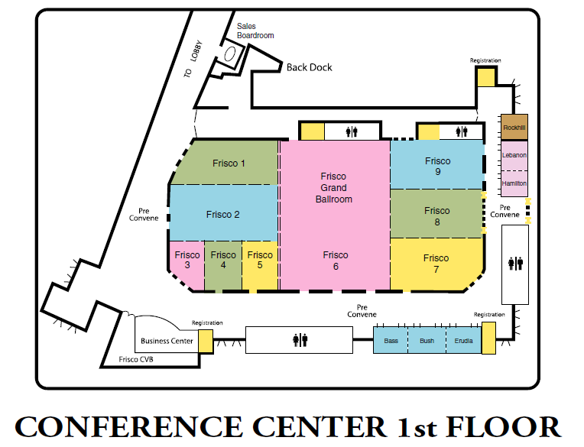

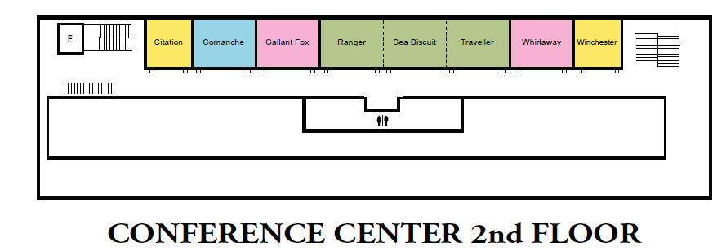

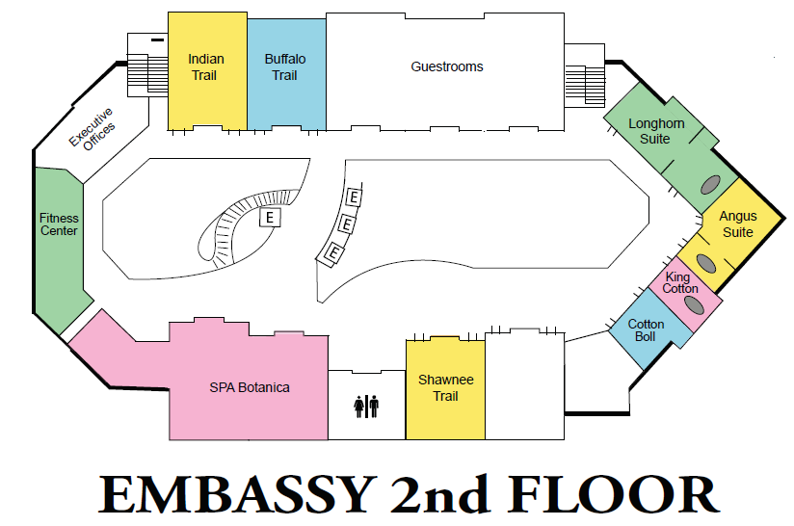

Future Conferences

2016 | October 16-18 | Embassy Suites San Marcos  Hotel, Spa & Convention Center
2017 | October 22-24 | Omni Corpus Christi

The Call for 2016 Conference Proposals will be available spring 2016

www.csotteconference.com

